Experiment 6
Shell Scripting – Set 2 29/03/2019

1. Write a shell script that displays a special listing showing the
permissions, size filename and last modification time of filename
supplied as arguments. Provide suitable headers using the printf
command.

Algorithm
1 If $# is zero then go to step 6
2 Read the file name in file
3 if the file with the name doesnt exist go to 6
4 Store the file name ,permission,size,date
5 Print stored details
6 Exit

schell script
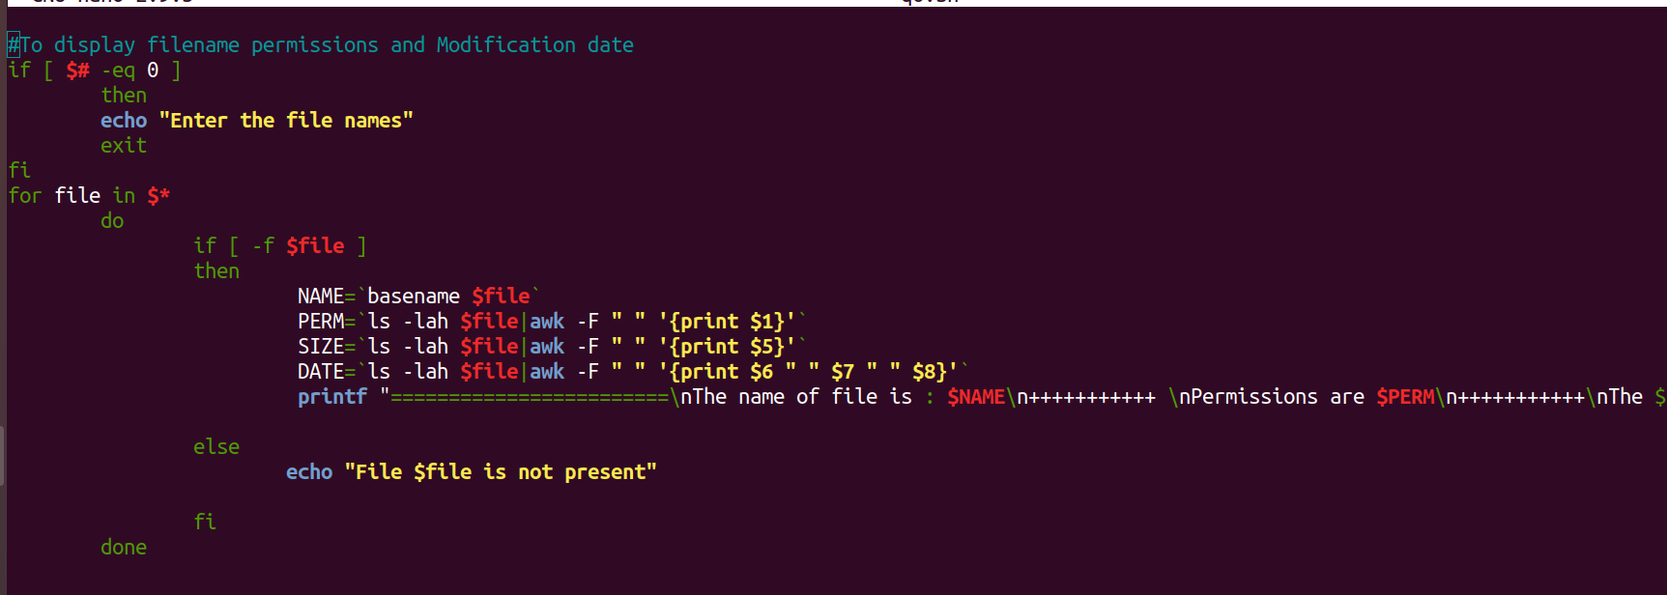
output

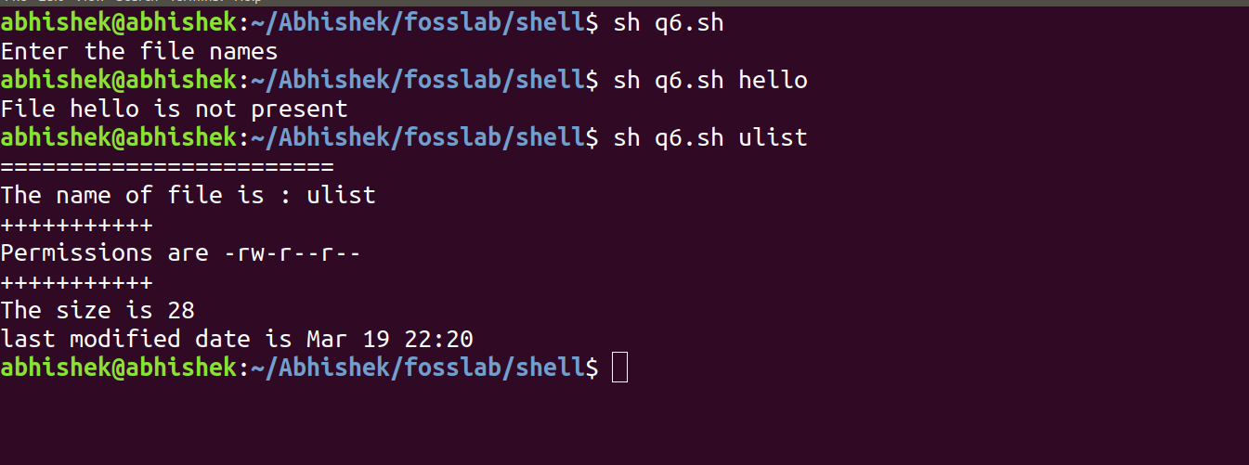
2. Write a script that compares two directories dir1 and dir2(supplied as
arguments) and copies to dir1 from dir2 every file that is not present in
dir1.
Algorithm
1 if $# not euql to 2 go to step 6
2 if both directories deosnt exist go to step 6
3 store the name of second directory
4 checking the files in second directory which is absent in first directory
5 copying unique files in directory 2 to 1
6 exit

schell script
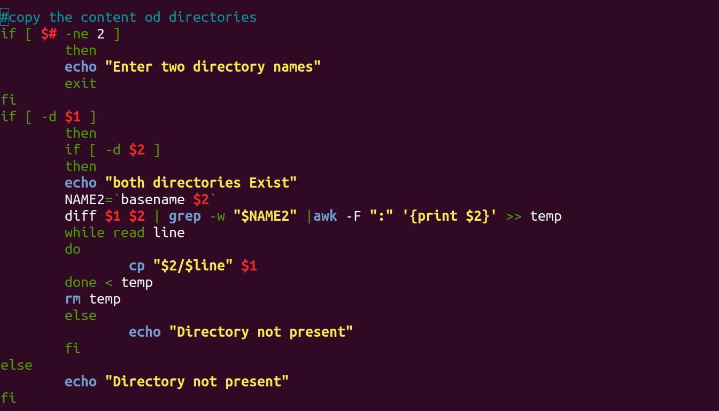
output
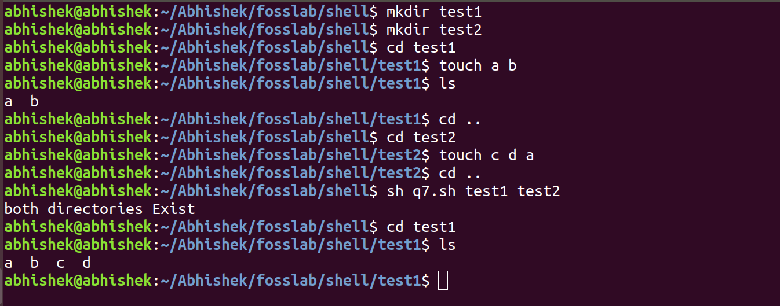
3. Write a shell script that accepts two file names as arguments, checks if
the permissions for these files are identical and if the permissions are
identical,output common permissions and otherwise output each file
name followed by its permissions.

Algorithm
1 if $# not equal to 2 go to step 7
2 if both files doesnt exist go to step 7
3 store the permissions of two files in PERM1, PERM2
4 if PERM1=PERM2 do 4 else do 6
5 print common permission go to 7
6 print both permissions
7 exit
Schellscript
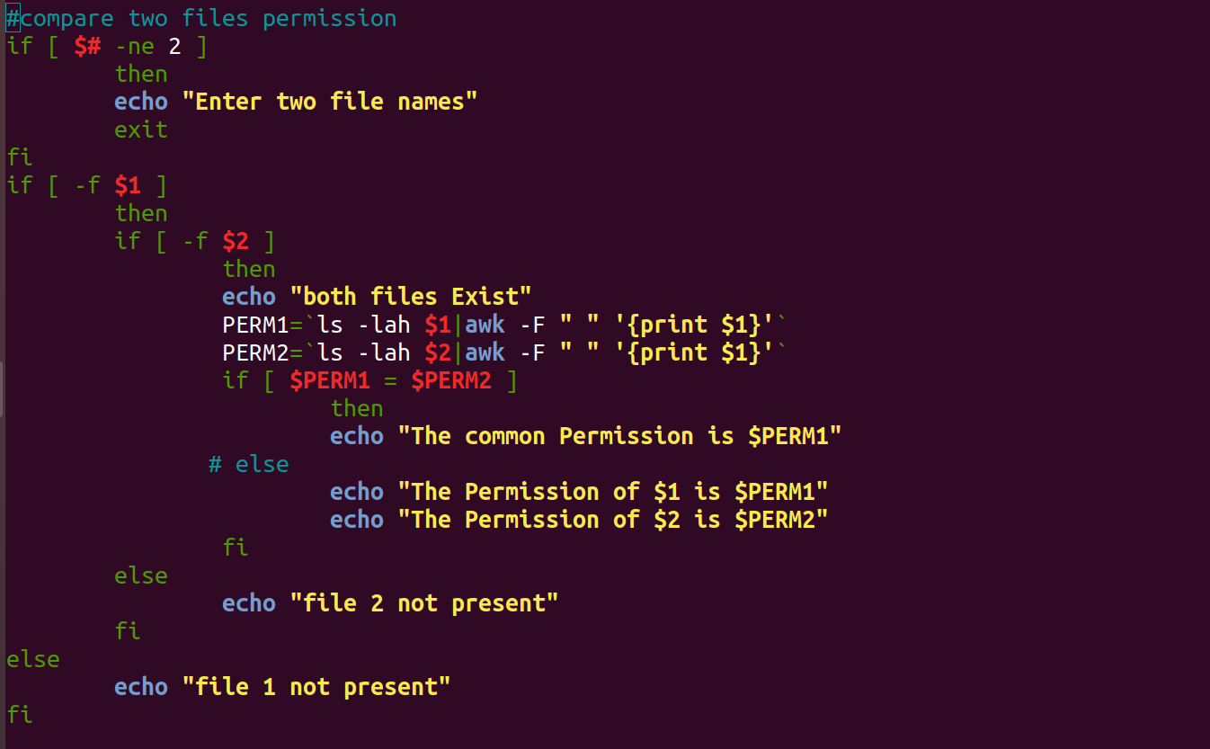
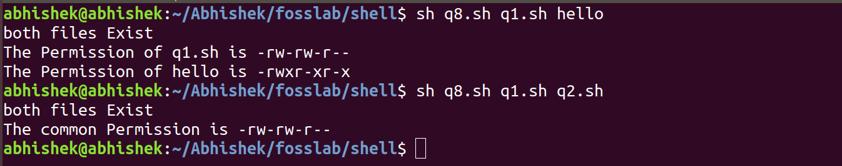
output
4. Write a shell script which receives two file names as arguments. It
should check whether the two file contents are same or not. If they are
same then second file should be deleted.

Algorithm

1 if #$ is not 2 go to step 5
2 if both files doesnt exist go to step 5
3 compare the content of two files
4 if contents are same remove second file else go to 5
5 exit

Schell script

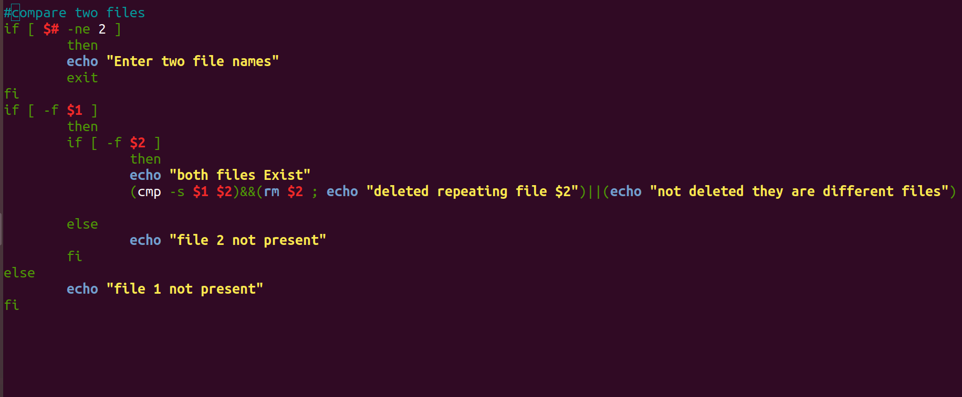
output
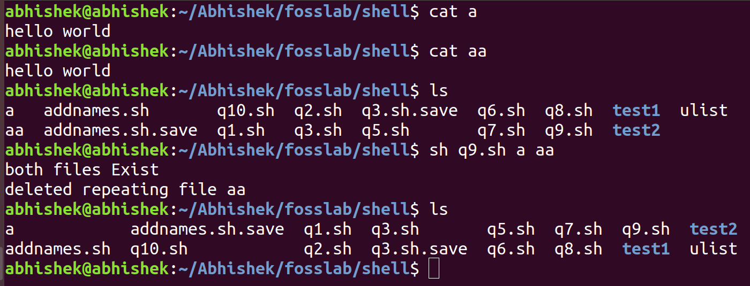

5. Write a shell script that, given a file name as the argument will count
vowels, blank spaces, characters, number of line and symbols.

Algorithm

1 if #$ not equal to 1 go to step 8
2 if file doesnt exit go to step 8
3 store number of spaces Space=`grep -o ' ' $1 | wc -l`
4 store number of charecters Chr=`wc -c $1 | awk '{print $1}'
5 store number of lines Line=`wc -l $1 | awk '{print $1}'`
6 read the file charecter by charecter and store in c
7 if vowel found increment vowel count
6 if special charecter found ,increment special charecter count
7 print Space,Chr,Line,v,Sym
8 exit
Schell script
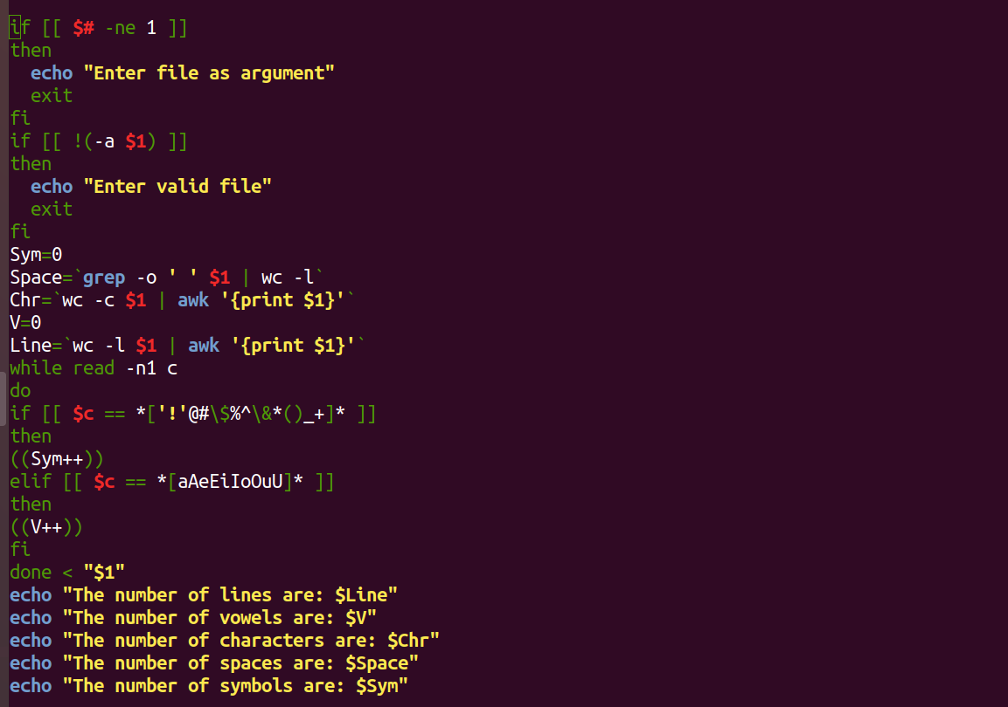

output
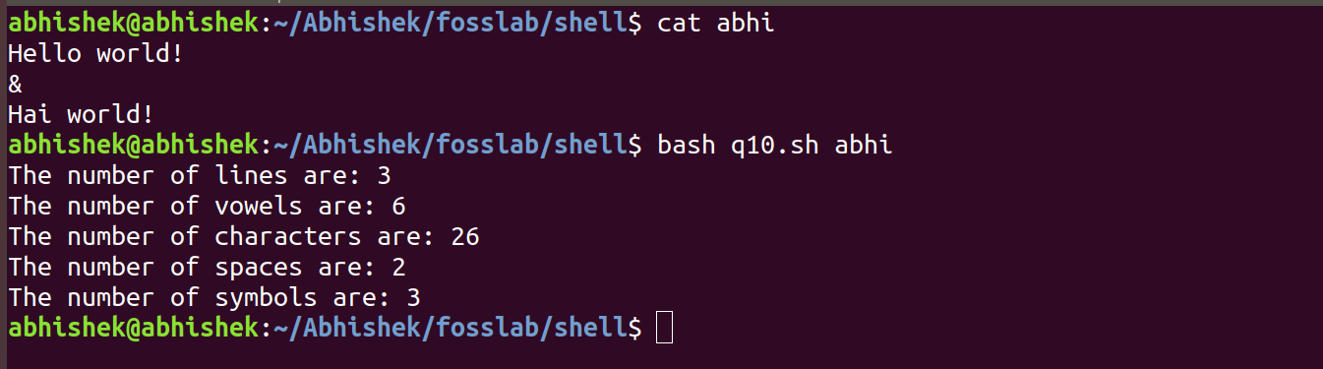

Submitted by
Abhishek manoharan
Roll no 2
S4 CSE

